COVID-19 Telehealth Program Application

Filing Instructions

OMB Control No. 3060- 1271

Contents
COVID-19 Telehealth Program Overview 3
Resources for Applicants 4
- Who Can Apply? 5
- What Must be Submitted? 6
  - General Information 6
  - Medical Services to be Provided with COVID-19 Telehealth Funding 7
  - Conditions to be Treated with COVID-19 Telehealth Funding 7
  - Additional Information Concerning Requested Services and Devices 7
  - Requesting Funding Items 8
  - Supporting Documentation 8
IV. How to Apply 9

COVID-19 Telehealth Program Overview
On April 2, 2020, the Federal Communications Commission (FCC) adopted a Report and Order establishing the COVID-19 Telehealth Program. The COVID-19 Telehealth Program will provide
$200 million in funding, appropriated by Congress as part of the Coronavirus Aid, Relief, and Economic Security (CARES) Act, to help health care providers provide connected care services to patients at their homes or mobile locations in response to the novel Coronavirus 2019 disease (COVID-19) pandemic. The COVID-19 Telehealth Program will provide immediate support to eligible health care providers responding to the COVID-19 pandemic by fully funding their telecommunications services, information services, and devices necessary to provide critical connected care services until the program’s funds have been expended or the COVID-19 pandemic has ended.

The application for the COVID-19 Telehealth Program, FCC Form 5636, is designed to obtain information from applicants that will be used by the FCC to evaluate and select applications to receive funding. The information is necessary to confirm eligibility, prioritize applications that target areas hardest hit by the COVID-19 pandemic, and determine funding award amounts.
Applications will be reviewed as they are received, and funding awards will be made on a rolling basis.

For more information regarding the COVID-19 Telehealth Program, please refer to the COVID- 19 Telehealth Program webpage at https://www.fcc.gov/covid19telehealth.

For more information regarding the FCC’s Coronavirus response, please see:
https://www.fcc.gov/coronavirus.

Resources for Applicants

Eligibility Determination
For specific questions about eligibility and completing the eligibility form (FCC Form 460), contact USAC via telephone at (800) 453-1546 or via email at: RHC-Assist@usac.org.

CORES (Commission Registration System)
If you need assistance with CORES, please contact the FRN Help Line at 877-480-3201 (M-F 8am-6pm ET) or submit a help request at https://www.fcc.gov/wireless/available-support - services.

COVID-19 Telehealth Program
For specific questions about the application, please email TelehealthApplicationSupport@fcc.gov.

For all other questions, please email EmergencyTelehealthSupport@fcc.gov.

Who Can Apply?
Health care providers seeking to participate in the COVID-19 Telehealth Program must obtain an eligibility determination from the Universal Service Administrative Company (USAC) for each health care provider site that they include in their application.
Health care provider sites that USAC has already deemed eligible to participate in the Commission’s existing Rural Health Care (RHC) Programs may rely on that eligibility determination for the COVID-19 Telehealth Program.

Health Care Provider Sites Without a Current USAC Eligibility Determination:

  - Interested health care providers that do not already have an eligibility determination may obtain one by filing an FCC Form 460 (Eligibility and Registration Form) with USAC.
  - FCC Form 460 can be filed through My Portal on USAC’s website at https://www.usac.org/rural-health-care/resources/my-portal/. (Filers do not need to be rural health care providers in order to file Form 460 for this purpose.)
  - Applicants that have not yet received an eligibility determination from USAC can still file an application with the Commission for the COVID-19 Telehealth Program while their FCC Form 460 is pending with USAC.
  - Consortium applicants may file an FCC Form 460 on behalf of member health care providers if they have a Letter of Agency.
  - Contact USAC for specific questions about eligibility and completing the eligibility form (FCC Form 460) via telephone at (800) 453-1546 or email at: RHC-Assist@usac.org.

All applicants to the COVID-19 Telehealth Program must also:

  - Obtain an FCC Registration Number (FRN) from the Commission Registration System (CORES), as well as a CORES username and password at that link. An FRN is a 10-digit number that is assigned to a business or individual registering with the FCC and is used to identify the registrant’s business dealings with the FCC. For more details on this process, see page 9 of this guide.
  - Register with the federal System for Award Management (SAM). For more details on how to register, please see page 26 of this guide.
(While applicants do not need to be registered with the SAM in order to submit an application, they will need to registered in order to receive funding, and the Bureau strongly encourages applicants to start that process early.)

What Must be Submitted?
In order to facilitate the application review process, applicants must complete each section of the application, submit documentation to support the funding requested, and make the required certifications at the end of the application. Specifically, health care providers must submit an application with sufficient information that will allow the Bureau to make selections and funding amount determinations. Please feel free to attach additional pages, as necessary, to respond to the questions on the application. Failure to provide the requested information may result in an application not being selected for funding under the COVID-19 Telehealth Program.
Applicants may request that any materials or information submitted to the Commission in its application be withheld from public inspection pursuant to the procedures set forth in § 0.459 of the Commission’s rules.

General Information:

  - Applicant Information:
    - Applicant Name
    - Applicant FCC Registration Number (FRN)
    - Applicant National Provider Identifier (NPI)
    - Federal Employer Identification Number (EIN/Tax ID)
    - Business Type (from Data Accountability and Transparency (DATA) Act Business Types) – Applicants may provide up to three business types.
    - DATA Act Service Area – This information will be required for each line item for which funding is requested. Applicants must enter name of the applicable state(s) or “nationwide.”

  - Contact Information:
    - Contact name for the individual that will be responsible for the application
    - Position title, Company Name
    - Phone number
    - Mailing address
    - Email address

  - Health Care Provider (HCP) Information (for each HCP that is part of the application):
    - Health care provider name (if there are multiple HCPs, the first is considered the
“lead” HCP)
    - Facility name
    - Indicate whether the facility is a hospital
    - Street address, city, state, county
    - FCC Registration Number (FRN)
    - Healthcare provider number from FCC Form 460
    - Eligibility type
    - National Provider Identifier (NPI)
    - Total patient population

    - Estimated number of patients to be served by the funding request (and supporting documentation)

Medical Services to be Provided with COVID-19 Telehealth Funding:

  - Patient-Based Internet-Connected Remote Monitoring
  - Other Monitoring
  - Video Consults
  - Voice Consults
  - Imaging Diagnostics
  - Other Diagnostics
  - Remote Treatment
  - Other services

Conditions to be Treated with COVID-19 Telehealth Funding:

  - Whether the applicant will treat COVID-19 patients directly
  - Whether the applicant will treat patients without COVID-19 symptoms or conditions
  - If the applicant will treat patients without COVID-19, identify the types of conditions to be treated or care to be provided (check all that apply):
    - Other infectious diseases
    - Emergency/Urgent Care
    - Routine, Non-Urgent Care
    - Mental Health Services (non-emergency)
    - Other conditions
  - How using COVID-19 Telehealth Program funding to treat patients without COVID-19 symptoms or conditions would free up resources that will be used to treat COVID-19

Additional Information Concerning Requested Services and Devices

  - Goals and objectives for use of the COVID-19 Telehealth Program Funding.
  - Timeline for deployment of the proposed service(s) or devices funded by the COVID-19 Telehealth Program.
  - Factors/metrics the applicant will use to help measure the impact of the services and devices funded by the COVID-19 Telehealth Program.
  - How COVID-19 has affected health care providers in the applicant’s area.
  - Any additional information about the geographic area and population served by the applicant. Indicate whether the geographic area served has been under any pre-existing strain (e.g., large underserved or low-income patient population; HCP shortages; rural hospital closures; limited broadband access and/or Internet adoption). If so, describe such factors.
  - Whether the applicant plans to target the funding to high-risk and vulnerable patients. If so, describe how.
  - Any additional information to support the application and request for funding.

Requesting Funding Items

  - Total amount of funding requested
  - Whether funding for devices is being requested. If so:
    - How are the devices integral to patient care?
    - Are the devices for patient use?
    - Are the devices for the health care provider’s use?

Supporting Documentation
Applicants should provide supporting cost documentation (e.g., an invoice or a vendor quote) for all eligible services and devices for which funding is requested. The detailed line item information that is strongly encouraged for all eligible services and devices for which funding is requested includes:

  - Category
  - Description of service(s) and/or device(s)
  - Quantities of services or devices
  - Total one-time expense
  - Total monthly expense
  - Expense date purchased or to be purchased
  - Service dates for recurring services

When to Apply
Applications may be submitted through the FCC’s COVID-19 Telehealth online portal, accessible at https://www.fcc.gov/covid19telehealth. Funding determinations will be made on a rolling basis until program’s funds have been expended or the COVID-19 pandemic has ended.

How to Apply
Applications may be submitted through the FCC’s COVID-19 Telehealth online portal, accessible at https://www.fcc.gov/covid19telehealth. Applicants who have already started filling out the PDF form may submit their applications to TelehealthApplicationSupport@fcc.gov.

The Commission’s hand-delivery filing location is closed and cannot be used to submit applications for the COVID-19 Telehealth Program. A copy of each completed application filed will be automatically filed in ECFS at a later date. Confidential information should not be included on the application form itself. Any confidential information for an application should be submitted as an attachment. Applicants will have an opportunity to request confidential treatment for confidential information included an attachment. This option is located on the Purpose and Intent tab.

Obtain an FCC Registration Number (FRN)
All applicants, like all other entities doing business with the Commission, must register for an FRN in the Commission Registration System (CORES). An FRN is a 10-digit number that is assigned to a business or individual registering with the FCC. This unique FRN is used to
identify the registrant’s business dealings with the FCC.

To register with CORES, please use the following link: https://apps.fcc.gov/cores/userLogin.do
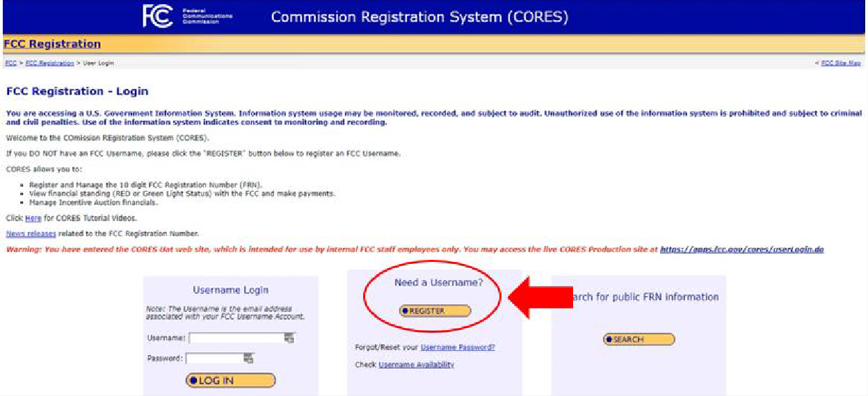

The first step to setting up an account in CORES is creating a username and account in the FCC User Registration System. Before the account is activated, the user will receive an

automated email titled “FCC Account Request Verification” and must verify its account
email address as prompted.

Once the user is logged in to CORES, the user should select the “Register New FRN” or “Associate Username to FRN” option as applicable from the menu options that appear and provide the information as prompted by CORES.
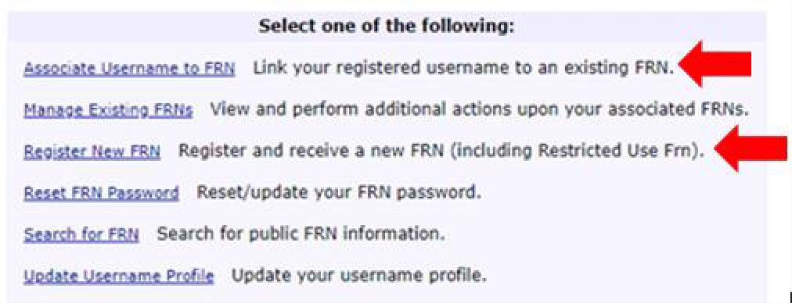

Users will need to provide their taxpayer identification number or TIN to register. The TIN is a nine-digit number that the Internal Revenue Service (IRS) requires of all individuals, businesses, and other employers to identify their tax accounts with the IRS. Once the user provides the information required in CORES and clicks “Submit,” CORES will generate a new FRN or associate the user’s existing FRN with its account.

Sign In and Start a New Form:

Navigate to https://www.fcc.gov/covid19telehealth and select “Submit an Application Online.” You will then be directed to a log in screen. Log into the system using your CORES username and password:
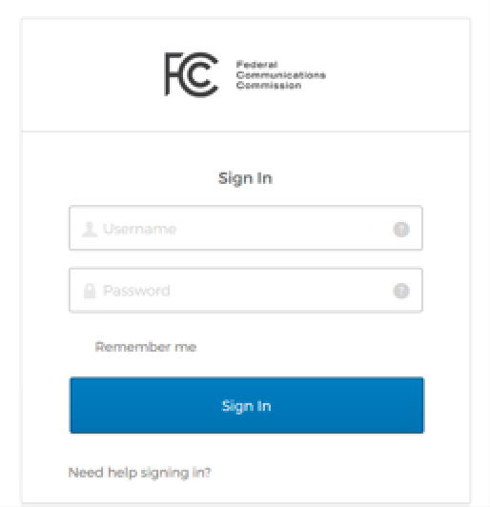

If you have not created a CORES username and password, you must do so through the
FCC’s CORES webpage at https://apps.fcc.gov/cores/userLogin.do.

After you log in, you will be directed to the COVID-19 Telehealth program landing page, shown below. To initiate an application, click the “Start a New Application” button.

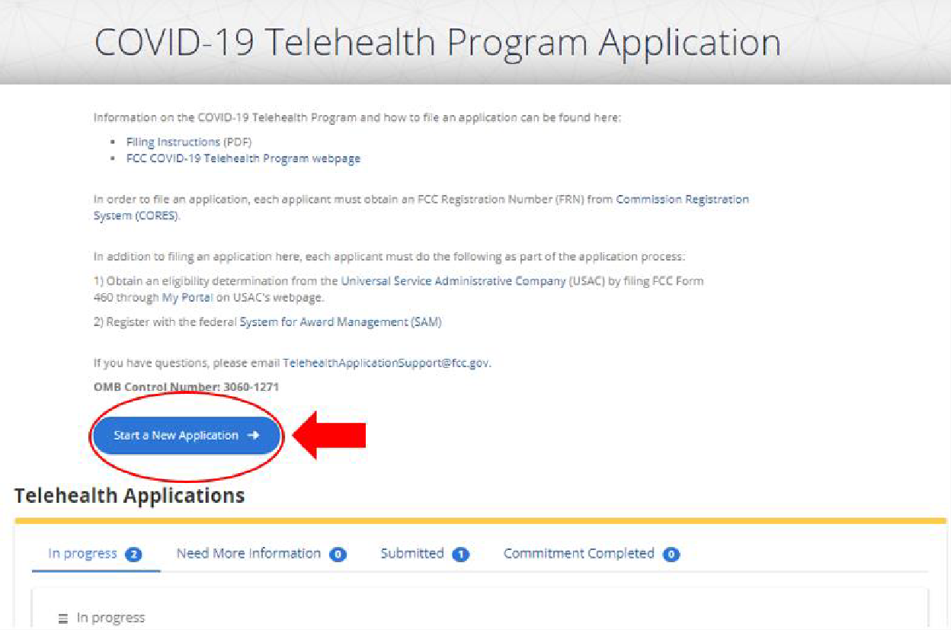

Tips for Navigating the Application:

- Fully and accurately complete all fields on the form marked with an asterisk (*). These fields are required and you must answer them for your application to be complete. Required fields are also noted in the instructions.
- To answer questions that require a more detailed response, consider drafting your response in a separate document and then copying and pasting that response into your application.
- Save the form often to preserve your work; we recommend that you fully complete each section and then save that section by clicking save at the bottom of the page before moving to a new section.

Enter Applicant Information

The unpopulated form shown below should appear:
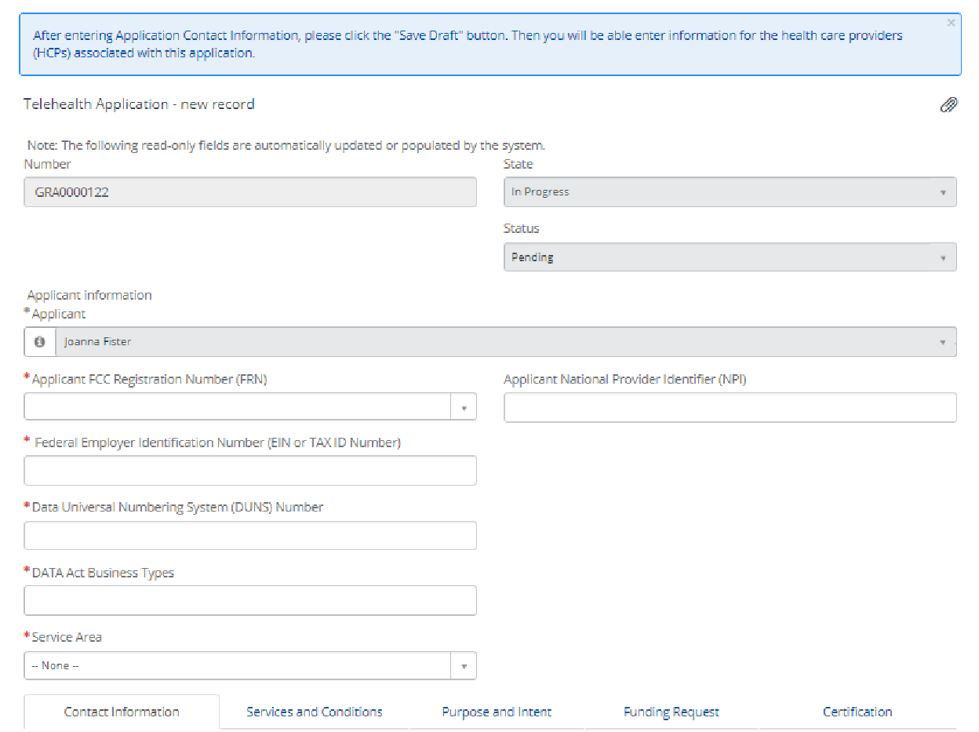
The Applicant Name is automatically populated from CORES and should be the person certifying the application. Applicants should list the Health Care Provider name(s) in the HCP Information tab in step 5.

Please Note: A consortium filing for multiple health care providers should use the information of the lead entity for this section.
  - Applicant FCC Registration Number (FRN) – Select your FCC Registration Number from the drop-down menu in the box labeled FRN by typing the first few numbers. This field is required.
  - Applicant National Provider Identifier (NPI) – Enter your 10-digit NPI obtained from the National Plan and Provider Enumeration System. This field is optional.
  - Federal Employer Identification Number (EIN or TAX ID Number) – Enter your EIN or Tax ID number. This field is required.
  - Data Universal Number System (DUNS) Number – Enter your unique business identifier. This information is required by the 2014 Digital Accountability and Transparency Act (DATA Act). This field is required.

Enter DATA Act Business Types
From the dropdown menu, choose three Business Types that best describe the organization. These selections will be reported as part of the DATA Act and are required.
Below is a list of the different Business Types and their description:
Code | Code Label | Code Description
A | State Government | The recipient is a U.S. state government.
B | County Government | The recipient is a U.S. county government.
C | City or Township government | The recipient is a U.S. city or township  government
D | Special District Government | The recipient is a special district government
E | Regional Organization | The recipient is a U.S. regional organization
F | U.S. Territory or Possession | The recipient is a U.S. territory or possession
G | Independent School District | The recipient is a U.S. independent school district
H | Public/State Controlled  Institution of Higher Education | The recipient is a U.S. Public/State Controlled  Institution of Higher Education
I | Indian/Native American Tribal  Government (Federally Recognized) | The recipient is an Indian/Native American Tribal  Government (Federally Recognized)
J | Indian/Native American Tribal Government (Other than Federally  Recognized) | The recipient is an Indian/Native American Tribal Government (Other than Federally Recognized)
K | Indian/Native American Tribal  Designated Organization | The recipient is an Indian/Native American Tribal  Designated Organization
L | Public/Indian Housing Authority | The recipient is a Public/Indian Housing Authority
M | Nonprofit with 501C3 IRS Status (Other  than an Institution of Higher Education) | The recipient is a Nonprofit with 501C3 IRS Status  (Other than an Institution of Higher Education)
N | Nonprofit without 501C3 IRS Status (Other than an Institution of Higher  Education) | The recipient is a Nonprofit without 501C3 IRS Status (Other than an Institution of Higher  Education)
O | Private Institution of Higher Education | The recipient is a Private Institution of Higher  Education
P | Individual | The recipient is an Individual
Q | For-Profit Organization (Other than Small  Business) | The recipient is a For-Profit Organization (Other  than Small Business)
R | Small Business | The recipient is a Small Business
S | Hispanic-serving Institution | The recipient is an Hispanic-serving Institution
T | Historically Black College or University  (HBCU) | The recipient is a Historically Black College and  University (HBCUs)
U | Tribally Controlled College or University  (TCCU) | The recipient is a Tribally Controlled College or  University (TCCUs)
V | Alaska Native and Native Hawaiian  Serving Institutions | The recipient is an Alaska Native and Native  Hawaiian Serving Institutions
W | Non-domestic (non-U.S.) Entity | The recipient is a Non-domestic (non-U.S.) Entity
X | Other | The recipient is not covered under any of the  other categories above
  - Service Area – Enter the state where applicant provides service or select “nationwide.”
Data Act Disclosure - The Name, Address, DUNS Number and Business Type will be disclosed in accordance with Federal Funding Accountability and Transparency Act of 2006 (FFATA)/DATA Act reporting requirements.

Enter Contact Information

You will then see a tab asking for additional information regarding your contact information, shown below:
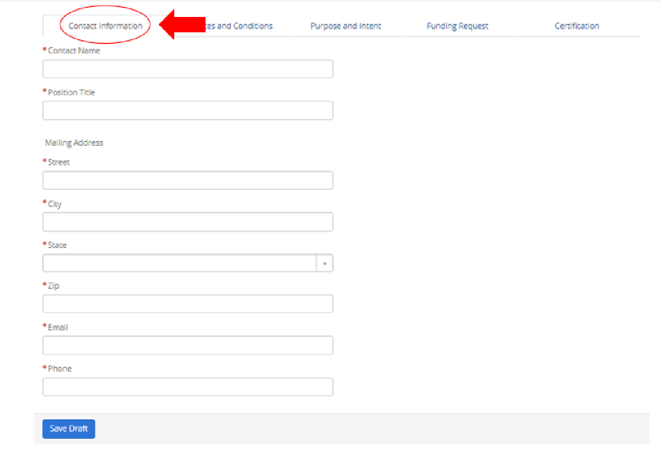
  - Contact Name – Enter the name of the contact person for the application.
  - Position Title, Company Name – Enter the position title of the contact person for the application and their company name.
  - Email – Enter the email address of the contact person for the application.
  - Phone – Enter the phone number of the contact person for the application.
  - Mailing Address – Enter the street, city, state, and zip code of the contact person for the application.
After entering Application Contact Information, please click the ‘Save Draft’ button. Then you will be able to enter information for the health care providers associated with this application.

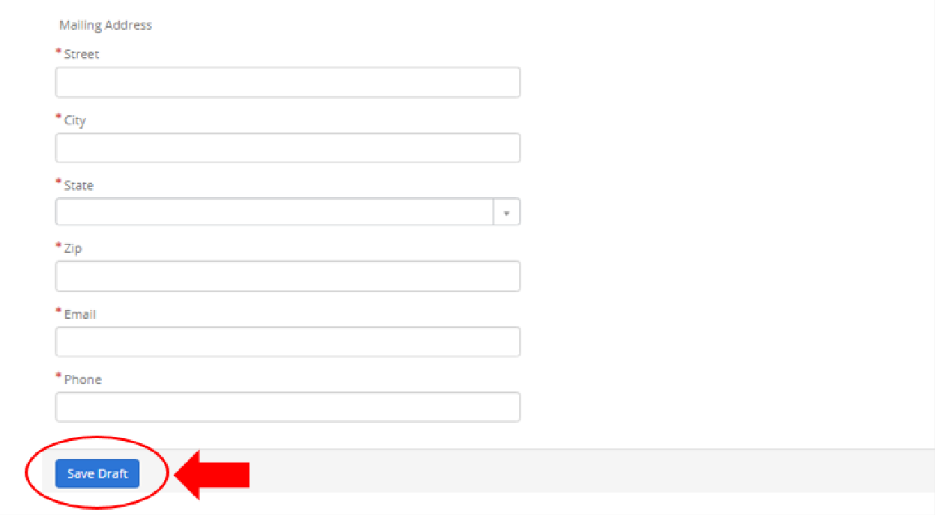

After clicking “Save Draft” button, the Health Care Provider tab will appear, as shown below. Click
“New” to enter the Health Care Provider Information.
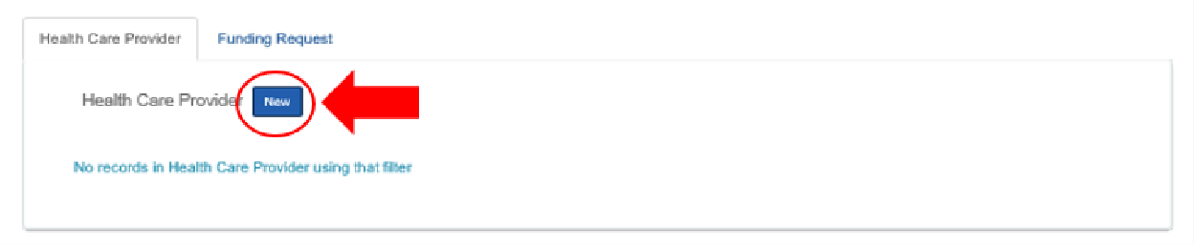

Enter Health Care Provider (HCP) Information

Upon clicking “New,” you will then be directed to an unpopulated form shown below:
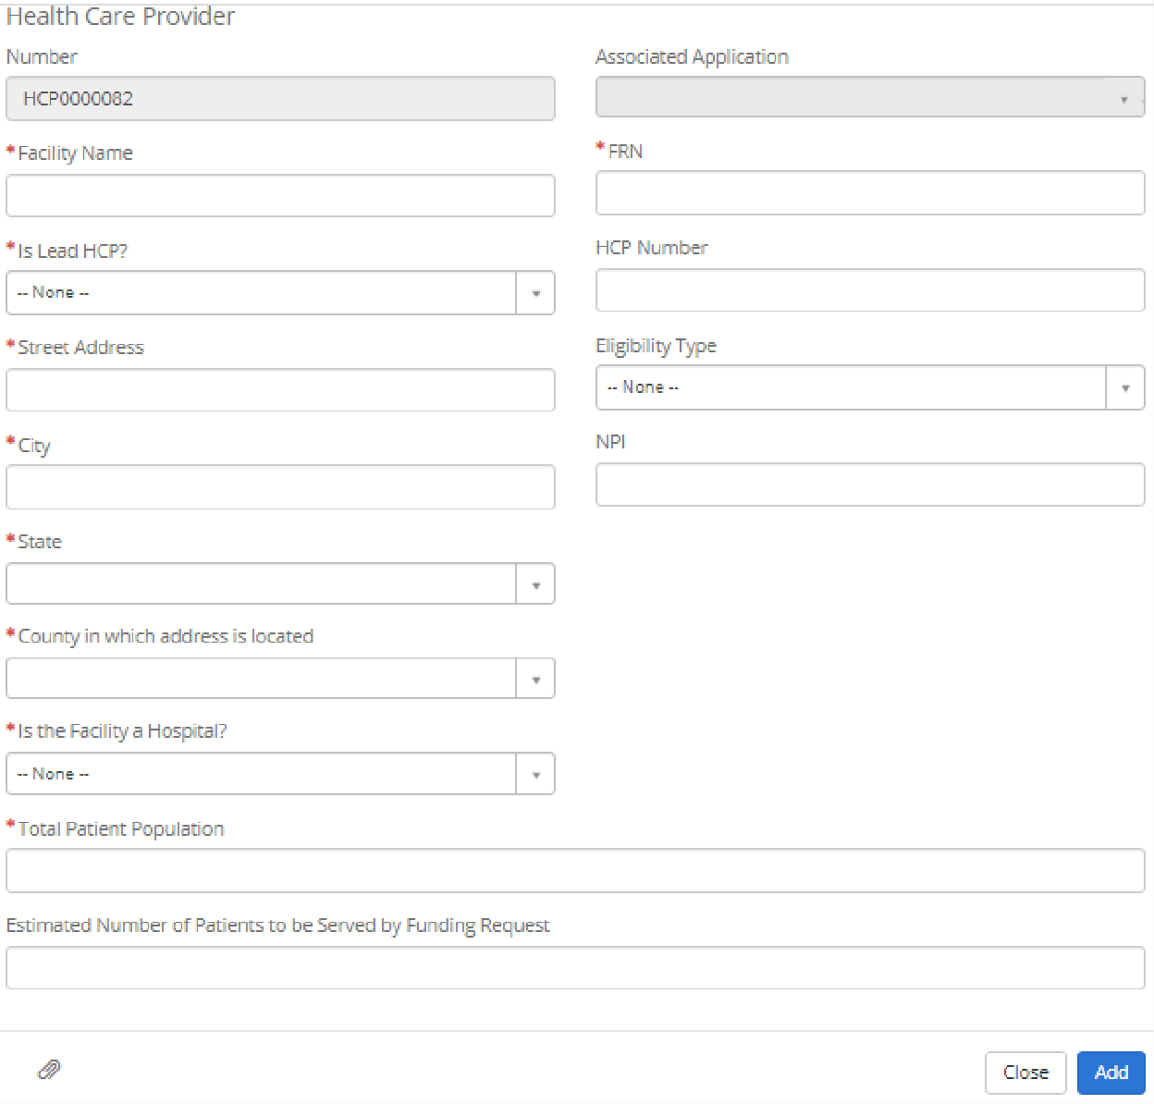
Please Note: A consortium filing for multiple health care provider sites must fill out a new health care provider tab for each site it is filing on behalf of.
  - Facility Name – Enter the health care provider facility name or name of lead entity for a consortium. This field is required.
  - FRN – Enter the FCC Registration Number for each health care provider (or entity). This field is required.
  - Is Lead HCP – Select “yes” if this provider (or entity) is the lead for the application.
Select “no” for all additional health care provider site. This field is required.
  - HCP Number – Enter the HCP Number assigned from FCC Form 460. This field is optional.

  - Eligibility Type – Enter the eligibility type selected on your FCC Form 460. This field is optional. Health Care Provider Eligibility Types eligible for funding under the COVID-19 Telehealth Program include:

(1) post-secondary educational institutions offering health care instruction, teaching hospitals, and medical schools
(2) community health centers or health centers providing health care to migrants
(3) local health departments or agencies
(4) community mental health centers
(5) not-for-profit hospitals
(6) for-profit dedicated emergency rooms
(7) health clinics
(8) skilled nursing facilities
(9) consortia of health care providers consisting of one or more entities falling in categories (1)-(8)

  - Address – Entering the street address, city, and state where the health care provider (or entity) is located. This field is required.
  - NPI – Enter the 10-digit NPI obtained from the National Plan and Provider Enumeration System for the health care provider. This field is optional.
  - County – Enter the county where the health care provider is located. This field is required.
  - Is the Facility a Hospital? – Select “yes” if this provider is a hospital; otherwise select “no.” This field is required.
  - Total Patient Population – Enter the number of patients each health care provider site treats each year. This field is required. Applicants are encouraged to provide additional explanation or supporting documentation as an attachment.

XXXX pregnant and postpartum women annually across X facilities in Orange County, CA.

  - Estimated Number of Patients to be Served – Enter the total estimate of patients that will be served with the funds requested. This field is required. Applicants are encouraged to provide additional explanation or supporting documentation.

The proposed program will serve all [or all Medical] pregnant and postpartum women in Orange County, CA (approximately 38,000 patients annually).

Application Tip: Be sure to click “Save” after completing the HCP tab.

Enter Services and Conditions
You will then see a tab asking for additional information on services and conditions, shown below:
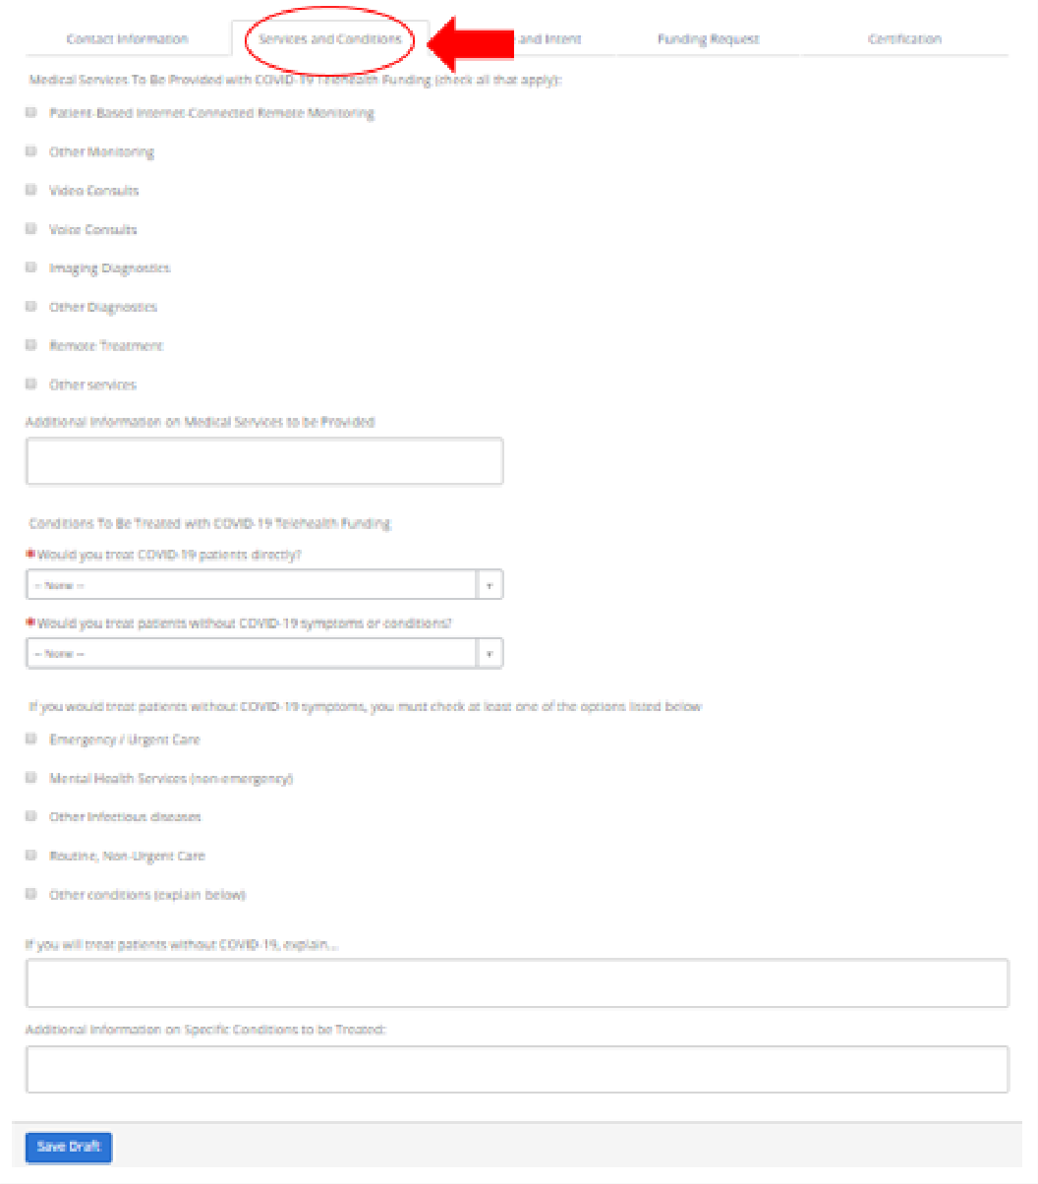
  - Medical Services to be Provided with COVID-19 Telehealth Funding – Check all medical services that the health care provider sites in the application plan to provide with requested funding. You are encouraged to provide additional explanation in the text box.

Check:
Video Consults
Voice Consults
Other: Patient Education (via app-based, rich-content push notifications)

Text Box:
__________ proposes to use the services of Pacify Health, an existing and successful vendor already in use at __________ as well a multitude of other healthcare and public health organizations (including a recent, COVID-specific program launched in partnership with the city of Philadelphia - https://www.inquirer.com/health/coronavirus-philadelphia-mothers-breastfeeding-lactation-counseling-pacify-free-20200330.html).

The Pacify app provides unlimited, 24/7 synchronous video consults with International Board-Certified Lactation Consultants and synchronous voice consults with Registered Nurses to pregnant and new mothers and their families. A HRSA-funded, randomized controlled trial administered by the RAND corporation showed that Pacify was effective at increasing the rate of exclusive breastfeeding as well as the overall duration of breastfeeding among mothers recently discharged from the hospital (insert citation). As the intervention targeted births at a Joint Commission-accredited, non-profit hospital system (serving six rural counties in rural North central Pennsylvania and South central New York), the study also established that the service was feasible and effective among rural patients, who were disproportionately Medicaid eligible (insert citation).

Video consults placed through Pacify’s telelactation service are answered in an average of less than 30 seconds on a 24/7 basis. The company has handled over 35,000 consults, primarily through contracts with Medicaid Managed Care companies (in AZ, NM, MO, IL, PA, MD, and DC) and with state or city government WIC programs (e.g., Philadelphia, Dallas, TN, MS, WV, VA, and DC) – all of which make the unlimited service available to mothers at no cost.

In addition to video lactation consults, the Pacify app also makes telephone nurse triage available to end users. Through partnership with URAC-accredited nurse advice provider AccessNurse, patients have 24/7 access to telephone nurse triage that utilizes the Schmitt-Thompson adult and pediatric triage protocols. These protocols have been updated to include COVID-specific triage workflows to appropriately advise patients based on their symptoms and exposure history.

  - Conditions to be Treated with COVID-19 Telehealth Funding – Identify whether you plan to treat patients with COVID-19 or other patients to free up resources. If you answer “yes” to treating patients without COVID-19 symptoms, you must select which conditions you will treat and explain how using this funding will free up resources to treat COVID-19. You are encouraged to provide additional explanation in the text box.

The proposed intervention will both treat patients with COVID-19 as well as other patients to free up existing healthcare resources for the treatment of COVID-19.

Direct treatment of potentially COVID-19 positive patients:

Both of Pacify’s clinical services will treat COVID-19 positive patients. The nurse triage service strictly adheres to and follows the Center for Disease Control’s (CDC) clinical care and response recommendations, which are verified and updated daily. Given the high levels of public anxiety and widespread misinformation, it is critical that new mothers and families have immediate and 24/7 access to a reliable and accurate clinical triage protocol administered by licensed Registered Nurses to determine if any symptoms they experience warrant testing or treatment, and what the appropriate action steps are.

A patient suspected of COVID-19 exposure is assessed using the Schmitt-Thompson COVID-19 Exposure protocol. After the patient assessment and based on the severity of the patient’s symptoms, the telephone triage nurse directs care as provided below:

For life-threatening and emergency symptoms (e.g., respiratory distress), the patient is directed to “call 911 now or proceed to the nearest Emergency Department accordingly.” The telephone triage nurse attempts to contact the ED to alert personnel of patient’s impending arrival. All patients referred for emergency care are instructed by the telephone triage nurse that they must inform the first person they see (or speak with if calling 911) of possible COVID-19 exposure.

All other patients with suspected COVID-19 exposure are directed to contact their primary care provider within the next 24 hours for further direction. The telephone triage nurse instructs all patients referred for a potential face-to-face visit that they must phone ahead before seeking care to inform personnel of possible COVID-19 exposure.

The important of accurate COVID-19 triage is not limited to adults. Data reviewed by the American Academy of Pediatrics also demonstrates that children of all ages are susceptible to SARS-CoV-2, and that infants under 1 year of age are at risk for severe disease. https://downloads.aap.org/AAP/PDF/COVID%2019%20Initial%20Newborn%20Guidance.pdf

With respect to lactation advice, nursing mothers today are experiencing extreme anxiety and are unsure how to safely feed their infants, particularly if they are or fear they may have been exposed to COVID-19. Again, widespread conflicting information about the safety of breastfeeding by COVID-19 positive mothers must be addressed by immediate and 24/7 access to reliable and clinically accurate advice from International Board-Certified Lactation Consultants. Additionally, it is well-established that anxiety and stress negatively impact a mother’s ability to produce milk. COVID-19 positive mothers will be able to receive accurate information on how to safely feed their infants.

Treatment of patients without COVID-19 symptoms:

Patients treated by telephone nurse triage for symptoms that are not related to COVID-19 will be less likely to seek unnecessary care at emergency departments, thus reducing exposure risk for those patients and freeing up Orange County hospital resources to treat COVID-19 positive patients. There is a host of evidence that telephone nurse triage reduces strain on emergency departments by lowering the site of care that patients choose for treatment of non-COVID-19 symptoms. For example, a 2007 study in Pediatrics showed that two-thirds of all calls for which a parent felt the patient should go to an emergency department or urgent care were deemed not to require an immediate evaluation by the telephone triage nurse (Bunik M, Glazner J, Chandramouli V, et.al. Pediatric telephone call centers: how do they affect health care use and costs? Pediatrics. 2007 Feb;119(2): e305-13). In another Pediatrics study, ED visits made by nurse telephone triage referral were 33% more appropriate than patients making self-decisions to go to the ED (80% vs. 60% of visits deemed appropriate - Barber JW, King WD, Monroe KW, et.al. Evaluation of emergency department referrals by telephone triage. Pediatrics. 2000;105:819-821) Finally, a study by investigators O’Connell and Johnson demonstrated that the implementation of telephone-based nurse triage service lowered utilization of hospital emergency department by 15% (O'Connell J, Johnson D, 1998 accessed at http://gateway.nlm.nih.gov/MeetingAbstracts/ma?f=102234357.html).

The combination of Pacify’s access to nurse triage and video lactation consultations has already been shown to contribute to reduced strain on ED facilities in Orange County. In a 2018 program with a local Orange County non-profit (MOMS OC), 850 low-income, MediCal eligible patients completed over 750 clinical consultations with the Pacify app. The results of that pilot showed the following:

* 26% decrease in ER visits
* 7.5% higher rate of breastfeeding at 6 months
* 6.9% higher rate of exclusive breastfeeding at 3 months

By supporting mothers as they try to continue breastfeeding, the need to seek formula at a grocery store can be avoided along with the ample health benefits available to breastfeeding mothers and their infants. According to the AAP, reduces the risk of Respiratory Tract Infections and Otitis Media, Gastrointestinal Tract Infections, Necrotizing Enterocolitis, Sudden Infant Death Syndrome and Infant Mortality, Allergic Disease, Celiac Disease, Inflammatory Bowel Disease, Obesity, Diabetes, Childhood Leukemia and Lymphoma. The benefits are more pronounced in preterm infants who experience short and long-term positive impacts such as a decrease in the occurrence of sepsis and NEC.

The health risks for the baby increase over time if critical newborn care points are missed. Pacify addresses these ongoing health concerns as well, thanks to a series of educational push notifications that remind mom when it is time to schedule and attend critical healthcare checkups for her and baby. This feature has shown increased infant vaccination rates and improved health outcomes in multiple state Medicaid programs across the country.

Studies show that breastfeeding concerns peak at days 3 & 7 postpartum, when 50% of mothers who initiate breastfeeding fail to achieve breastfeeding intentions citing difficulty with infant feeding at breast (52%), breastfeeding pain (44%), and milk quantity (40%). All of these issues are common complaints that can be resolved by Pacify's virtual IBCLCs without in-person follow up.
https://www.ncbi.nlm.nih.gov/pmc/articles/PMC3784292/ The AAP policy on breastfeeding shows continued link between mothers who breastfeed and short and long-term positive health outcomes. Statistically significant decreases in postpartum blood loss, postpartum depression, and more rapid involution of the uterus were demonstrated. Moreover, the AAP cites a study of over 139,000 women with a cumulative lactation history of 12 to 23 months that had a significant reduction in hypertension (OR: 0.89; 95% CI: 0.84–0.93), hyperlipidemia (OR: 0.81; 95% CI: 0.76–0.87), cardiovascular disease (OR: 0.90; 95% CI: 0.85–0.96), and diabetes (OR: 0.74; 95% CI: 0.65–0.84). https://pediatrics.aappublications.org/content/129/3/e827

Purpose and Intent

You will then see a tab asking for additional information on your purpose and intent for the requested funding, shown below:
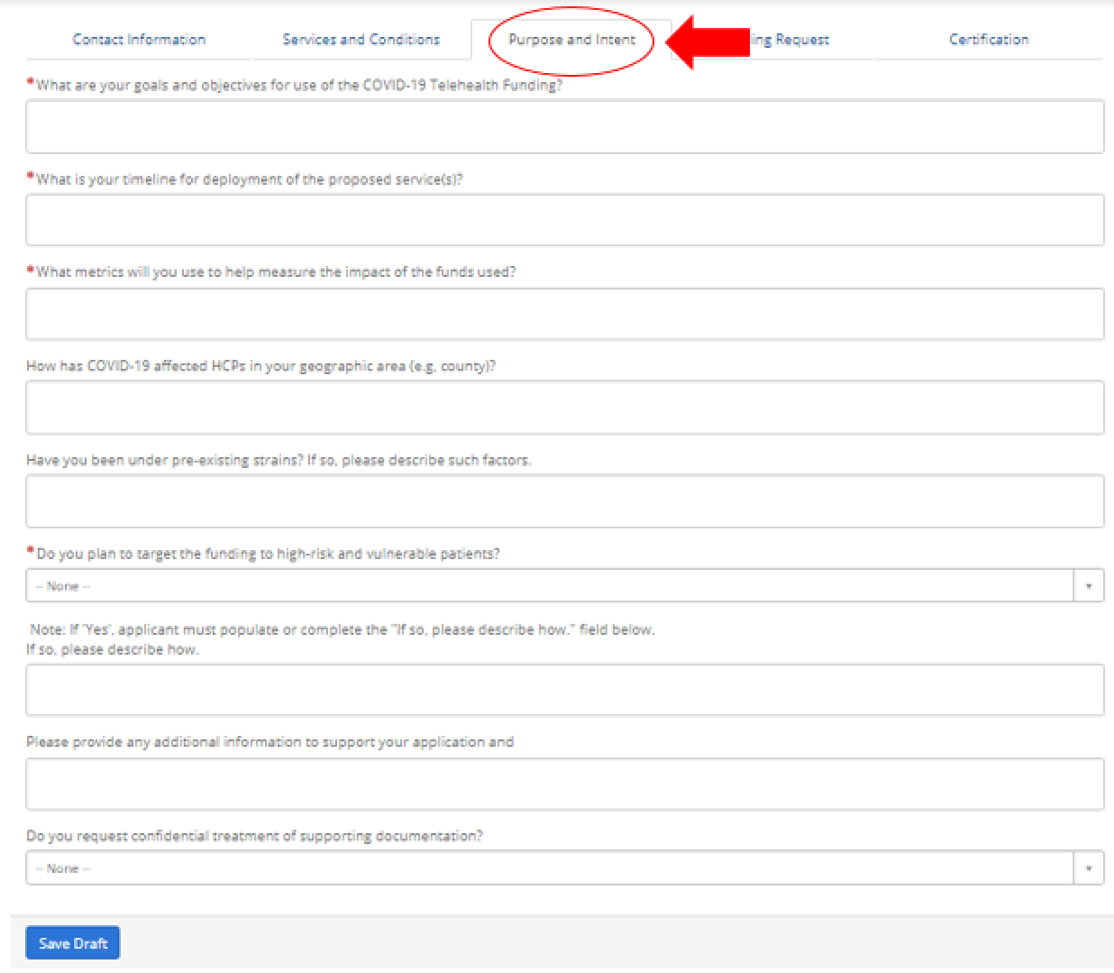

  - What are your goals and objectives for use of the COVID-19 Telehealth Program Funding – Please explain what you aim to accomplish with the funding requested. This question is required.

There are two sweeping goals for this program. The first Is to protect new mothers and babies in Orange County by substantially decreasing their need to seek in-person, emergency services throughout the COVID-19 crisis. For those parents, infants, and children who may have COVID-19 exposure or are experiencing symptoms, the goal is to instantly connect them to accurate triage and infant feeding advice. The second – and equally important - goal is to reduce the strain on Orange County hospitals’ emergency services by reducing unnecessary ED utilization through improved maternal and infant health post-discharge as well as accurate triage advice.
  - What is your timeline for deployment of the proposed service(s) or devices funded by the COVID-19 Telehealth Program? – Please explain the timing of purchase and deployment for the service(s) and devices you are requesting funding for. This question is required.

The proposed services can be deployed almost immediately, thanks to __________ Memorial Hospital's existing relationship with Pacify as well as Pacify’s history of partnership with other county non-profits serving low-income families. The contracting process will take no more than 5 business days and the technical implementation will be completed within 1 week. The brief implementation will consist of confirming triage clinical protocols, providing two hour-long staff trainings on the Pacify experience, and how to enroll patients in the platform. Once the tool is available for patients, the remaining efforts will consist of marketing to the Orange County area to alert them of the service and educate them on how to get free access to it.

NOTE TO __________: WE WILL RELY ON YOU GUYS TO ELABORATE ON DETAILS OF PROMOTING THE PROGRAM, KEY PARTNERS, ETC.

  - What factors/metrics will you use to help measure the impact of the services and devices funded by the COVID-19 Telehealth Program? – Please explain what factors and/or metrics you intend to use to measure the impact of the services and devices funded by the program. This question is required.

In order to measure the impact of the program, we will use data gathered by the Pacify app itself as well as information collected during a post-visit email survey.

Through the Pacify application, we will track the number of enrolled mothers in the program and the number of video lactation consultants and nurse triage calls placed. Nurse triage calls will be evaluated to determine the number of unnecessary ED visits avoided. We do this by calculating the number of callers whose initial disposition was to seek care at a county ED, but who received triage advice to use a lower site of care and – critically – who indicate an intention to follow that advice. We will also track the number of nurse advice calls that address COVID-19 symptoms.

Pacify users are also asked to rate each clinical experience on the app, so we will be able to assess patient satisfaction with the services by evaluating average star ratings and any optional qualitative feedback left in the app. The last app-based metric will be an evaluation of the number of lactation and nurse advice calls that addressed COVID-19 symptoms.

The post-visit email and call surveys will be used to determine the proportion of users who are or were at the time of service MediCal or WIC eligible, COVID-19 positive or exposed, veteran or active duty military, and/or members of a federally-recognized Indian tribal organization. Additionally, the post-visit survey will produce a Net Promoter Score by asking respondents how likely they would be to refer someone to use the service.
  - Please provide additional information about the geographic area and population you serve. – Please explain if your area has any pre-existing strain factors, such as a large underserved or low-income patient population, recent health care provider closures or other deficiencies. This question is optional.

Do you plan to target the funding to high-risk and vulnerable patients? -- Please
choose from the drop down either “yes” or “no.” This question is required.

YES. The funding will specifically target pregnant and recently postpartum women and their infants – an inherently vulnerable patient population. Additionally, approximately 50% of mothers and infants in Orange County live in households at or below 322% of the Federal Poverty Level and are eligible for MediCal coverage.

  - Additional Information for Targeting High Risk Patients -- If applicable, please elaborate on how you plan to target high risk patients with additional funding. This question is optional.

Add additional information needed on the high-risk nature of Medicaid patients (comorbidities, disproportionately dependent on jobs that make social distancing impossible, financial insecurity, lower rates of vaccination, timely postpartum care, etc.)

Key Poverty Statistics: Orange County’s cost of living is 87 percent higher than the U.S. average, but its median family income is just 42 percent above the national median (according to the 2018 Orange County Community Indicators Report). 16.9% of Orange County’s children were living in poverty in 2016 – higher than the general population’s poverty rate of 12.5% and (particularly alarming) an increase of 24% since 2010. Poverty among Orange County’s children is increasing faster than in California overall, which increased 15% since 2010. When the cost of housing is factored in, poverty among Orange County children jumps to 24.6%, surpassing California at 19.9%.

WE ARE DEFINITELY LOOKING FOR HELP WITH ELABORATING ON THIS SECTION
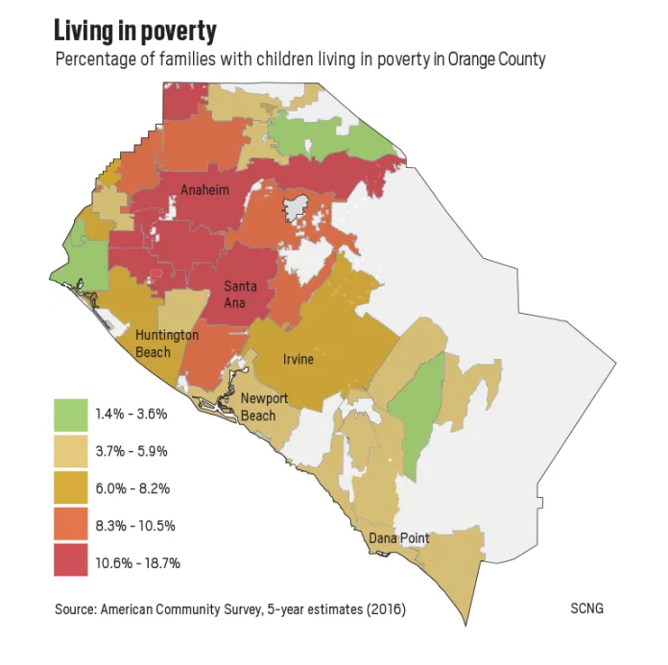

https://scng-dash.digitalfirstmedia.com/wp-content/uploads/2018/07/2018-OC-INDICATORS-REPORT.pdf

Confidentiality

By designating supporting documents and information as “Confidential,” the applicant is deemed to have submitted a request that the material be withheld from public inspection pursuant to 47 CFR § 0.459. Applicants designating documents as “Confidential” should not submit those documents in the FCC’s Electronic Comment Filing System.
To request confidential treatment of supporting documentation, answer “Yes” to the question on the bottom of the Purposes and Intent tab. Confidential information should not be included on the application form itself. Any confidential information should be submitted as an attachment.

Funding Requested

You will then see a tab asking for additional information on your funding request, shown below:
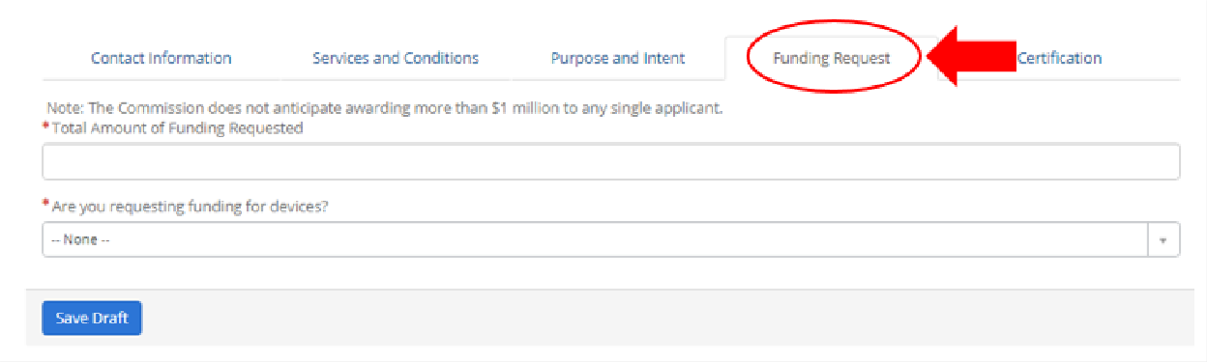

  - Please note: Applicants can only seek funding for (a) Internet/broadband or voice connectivity services and (b) devices that are connected to the internet or a broadband/voice network and used for patient care, monitoring, treatment, or diagnostics

Examples of services and devices that COVID-19 Telehealth Program applicants may seek funding for include:
    - Telecommunications Services and: Voice service .
    - Information Services: Internet connectivity services for health care providers or their patients; remote patient monitoring platforms and services; patient reported outcome platforms; store and forward services, such as asynchronous transfer of patient images and data for interpretation by a physician; platforms and services to provide synchronous video consultation.
    - Internet Connected Devices/Equipment: tablets, smart phones, or connected devices to receive connected care services at home (e.g., broadband enabled blood pressure monitors; pulse-ox; etc.) for patient or health care provider use; telemedicine kiosks/carts for health care provider site.

  - Total amount of funding requested – Please enter the total amount of funding in a dollar amount; please note that we do not anticipate awarding more than $1 million in funding to any one applicant. This question is required.

The total funding requested to make these services available on an unlimited basis for 12 months to the approximately __,000 births in Orange County is $___,000, or, approximately $__ per birth.

  - Are you requesting funding for devices – Please choose from the drop down either
“yes” or “no.” This question is required.

No.

  - How are devices integral to patient care – Please explain how these devices are necessary to provide care to your patient population. This question is required if you are requesting funding for devices.

N/A

  - Are the devices for patient use -- Please choose from the drop down either “yes” or “no.” This question is required if you are requesting funding for devices.

N/A

  - Are the devices for the health care provider’s use -- Please choose from the drop down
either “yes” or “no.” This question is required if you are requesting funding for devices.

N/A

Supporting Documentation

An applicant should provide supporting documentation for the costs indicated in its application. Such supporting documentation should summarize the expected costs of the eligible services and devices requested and may include documentation such as an invoice or quote from a vendor or service provider (or similar information). Such information should be specific enough to identify line-items to facilitate swift review of the application, and we encourage applicants to include information such as a description of the service or device, its eligibility category, the quantity ordered, the upfront and monthly expenses, and the service dates for recurring services.

Note: Supporting Cost Documentation is required material.

Supporting documentation can be attached at the top of the application, as shown below:
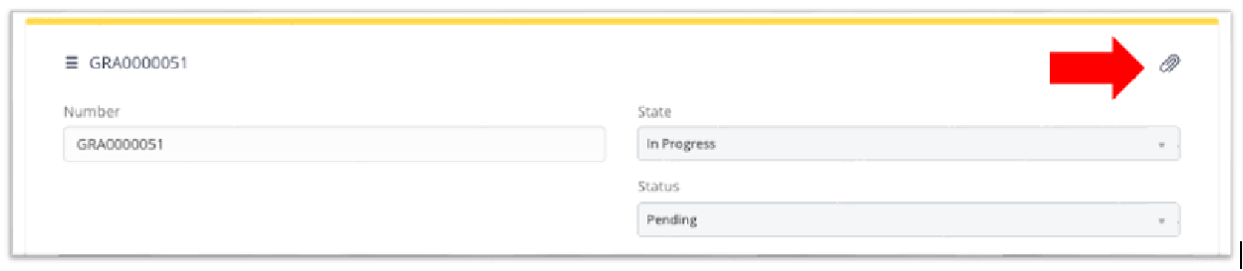

Applicants may also provide additional detail for the funding request in the funding request details table at the bottom of the page. Switch to the Funding Request Details tab, as shown below. Click “New” to enter these details.
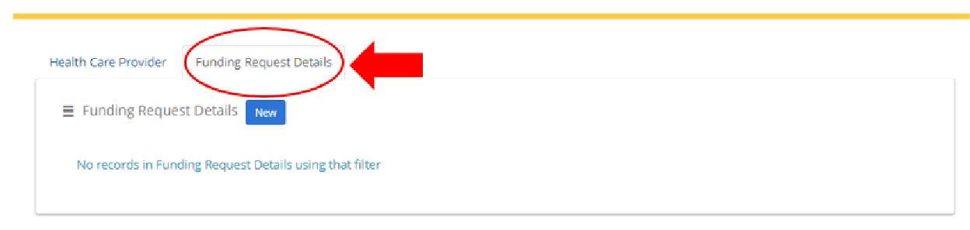
Upon clicking “New,” you will then be directed to an unpopulated form shown below:

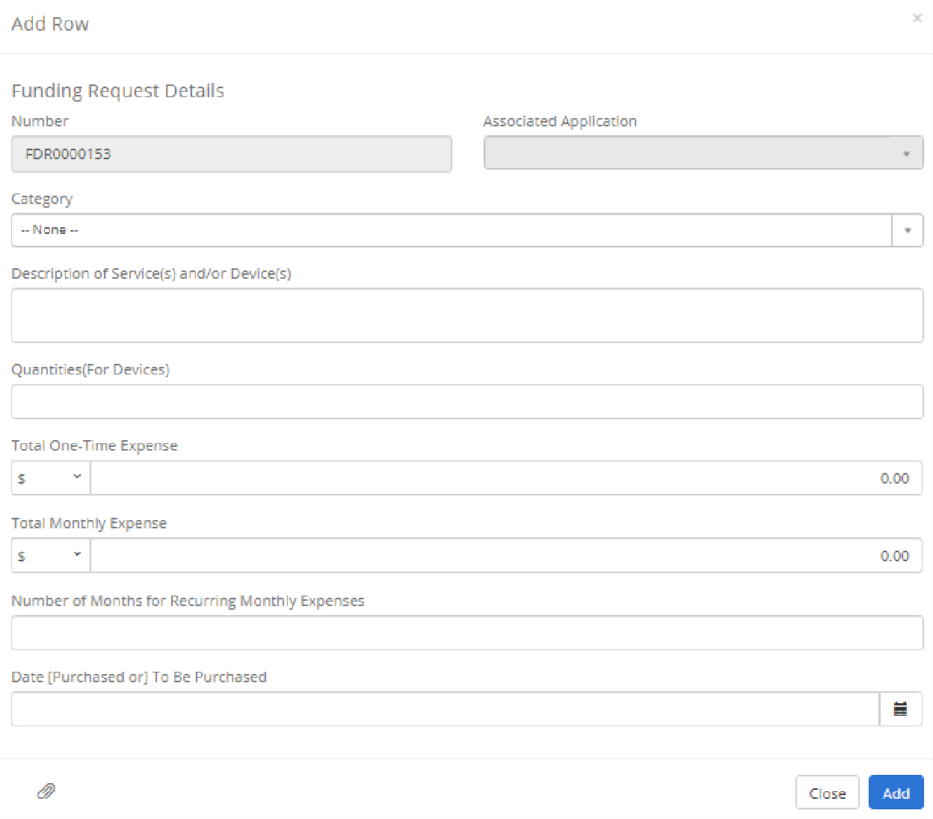
  - Category – Please select the category that best fits the line item. This field is optional.
  - Description of Service(s) and/or Device(s) – Please briefly describe the line item service or device(s) on the funding request. This field is optional.
  - Quantities (for devices) – Please enter the line item quantity for devices.
  - Total One-Time Expense – Please enter the total one-time expense associated with the line item. This field is optional.
  - Total Monthly Expense – Please enter the total monthly expense associated with the line item. This field is optional.
  - Date – Please enter the date the line service or device(s) were purchased or the date to be purchased. This field is optional.
  - Number of Months for Recurring Service – Please enter the total number of months for the line item. This field is optional.
Applicants can optionally create a new item in the funding request details table for each line item.
Application Tip: Be sure to click “Save” after completing the Funding Request Details tab.

Certify & Submit

When you are ready to submit the information, please click the “Submit” button on the certifications tab. Carefully read the language that appears in the Certify Submission pop- up window and click then click “Certify & Submit” button. See Certification below for more information.
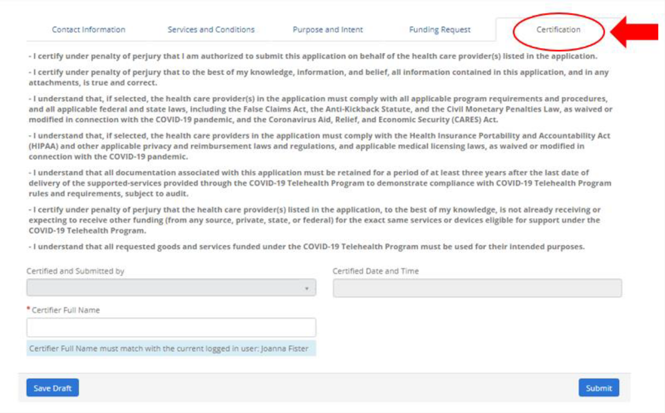

You will then see a confirmation of submission in green, shown below:
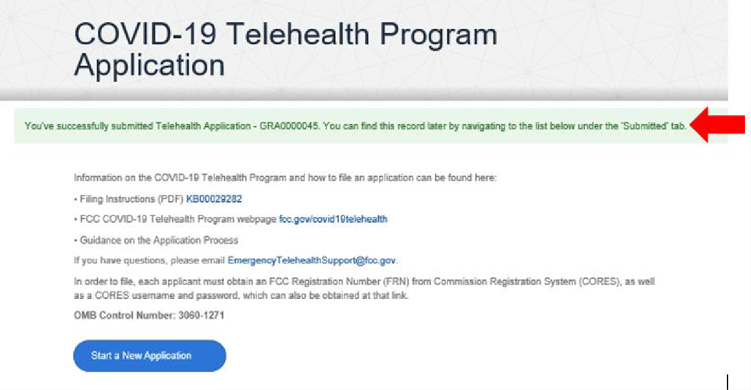

Revise an Application In Progress

Once you have saved a draft of a filing or submitted a filing, the filing will be listed under Telehealth Applications on the Covid-19 Telehealth Program landing page, below the “Start a New Form” button.

In Progress Status

Applications that have been saved but not submitted will be have a Status of “In Progress.” If you click on the application listed in the table, you can return to the
submission form to add to or change the information entered, and then click Save or Certify & Submit.

Submitted Status

Applications that have been certified and submitted (see Step 11 above) will have a Status of “Submitted” in the Telehealth Applications table. If you click on the link to a Submitted filing, you will be able to view the information you submitted for that filing.

Needs More Information Status

If your application needs additional information, application reviewers will contact you. You will then have the opportunity to revise your application and provide additional supporting documentation.

Final Steps:

Registering with System for Award Management:
To receive payments through the COVID-19 Telehealth Program, applicants must be registered with the federal System for Award Management. The System for Award Management is a web-based, government-wide application that collects, validates, stores, and disseminates business information about the federal government’s partners in support of federal awards, grants, and electronic payment processes. Many applicants may already be registered with the System for Award Management and do not need to re-register with that system in order to receive payment through the COVID-19 Telehealth Program.

Health care providers not yet registered with the System for Award Management may still submit an application. However, it is strongly recommended that unregistered health care providers start that registration process now because it may take up to 10 business days for your registration to become active and an additional 24 hours before that registration information is available in other government systems.

To register with the system:
Go to https://www.sam.gov/SAM/ with the following information:
  - (1) DUNS number;
  - (2) Taxpayer Identification Number (TIN) or Employment Identification Number (EIN); and
  - (3) Your bank’s routing number, your bank account number, and your bank account type, i.e. checking or savings, to set up Electronic Funds Transfer (EFT).

You will receive a confirmation email once the registration is activated. Only applicants registered through the System for Award Management will be able to receive COVID-19 Telehealth Program funding.

CARES Act Reporting Requirements

As part of this information collection and not later than 10 days after the end of each calendar quarter, each entity recipient that receives COVID-19 Telehealth Program funds that amount to more than $150,000 must submit to the FCC and the Pandemic Response Accountability Committee a report that contains—(A) the total amount of large covered funds received from the agency; (B) the amount of large covered funds received that were expended or obligated for each project or activity; (C) a detailed list of all projects or activities for which large covered funds were expended or obligated, including—(i) the name of the project or activity; (ii) a description of the project or activity; and (iii) the estimated number of jobs created or retained by the project or activity, where applicable; and (D) detailed information on any level of subcontracts or subgrants awarded by the covered recipient or its subcontractors or subgrantees, to include the data elements required to comply with the Federal Funding Accountability and Transparency Act of 2006 (FFATA) (31 U.S.C. 6101 note) allowing aggregate reporting on awards below $50,000 or to individuals, as prescribed by the Director of the Office of Management and Budget. Not later than 30 days after the end of each calendar quarter, the Committee, in consultation with the FCC will make this information publicly available by posting the information on the website established under section 15010(g).

